Solutions
Solutions are a very common type of homogeneous mixtures. A solution is formed when one substance (solute) dissolves in another (solvent).
For example, when sugar is mixed with water, the solute is the sugar and the solvent is the water. They form a sugar solution in which the sugar looks as if it has “disappeared” but tasting the solution will prove it is still there. Once dissolved, the sugar particles are too small and spread far too thinly throughout the water to be seen. This makes the solution transparent. Light is able to pass straight through. Solutions can also be made by dissolving a liquid in a liquid (alcohol in water = alcoholic drink), or a gas in a liquid (oxygen in water = allows fish to breathe).
If one substance can dissolve in another, it is said to be soluble. A substance that will not dissolve is called insoluble. For example, sand is insoluble in water.
Common solutions
Solute | Solvent | Common solutions
Carbon dioxide gas | Water | Soda water
Detergent | Water | Washing-up water
Oil | Petrol | Two-stroke motor mower fuel
Germ-killing chemicals | Water | Disinfectant
Nail polish | Acetone (nail polish remover) | (no common name)
Pen ink dyes | Methylated spirits | Pen ink

solvent
solute
solution

Concentration
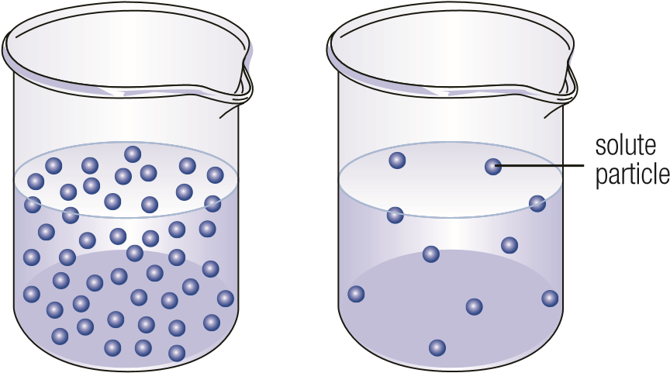
Concentrated dilute solution
solution

When a solvent contains a large amount of solute, the solution is said to be concentrated. The opposite of being concentrated is being dilute.
Adding more solute makes the solution more concentrated. Adding more solvent makes it more dilute.

Suspensions
A mixture of water and sand is not a solution, but is called a suspension.
In a solution, the size of the solute and solvent particles are similar. In a suspension, the particles being mixed are much bigger than in a solution. Initially they float around, suspended in the solvent. If left long enough, however, they settle to the bottom of the container. Some medicines and some paints are suspensions. They separate into different layers and need to be re-mixed before use.

Colloids
A colloid is in between a solution and a suspension. The particles in a colloid are bigger than those in a solution, but smaller than those of a suspension, and do not settle out as quickly. Milk is a colloid.
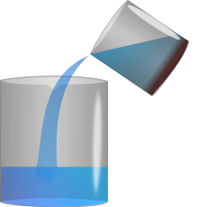
Separating Solutions
Decanting - suspensions
Decanting can be used to separate a solvent from a suspension that has settled out, and has a sediment at the bottom. Decanting is carefully pouring off the liquid from a sediment.
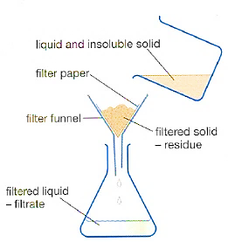
Filtering - suspensions
Evaporation and crystallisation
Solute particles are far too small to be able to be filtered. If the solvent is left to evaporate however, they will be left behind as crystals. Boiling the solution can speed up the process of evaporating the solvent.

Distillation – solutions and suspensions.
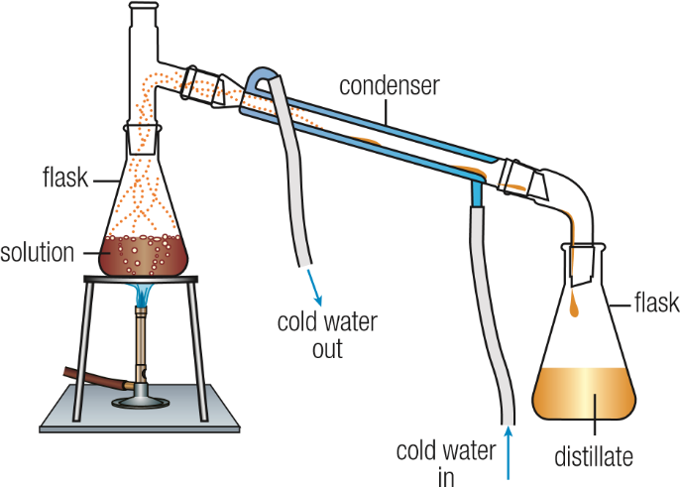
Distillation can be used to separate solutions made from a solid and a liquid, or a solution of two liquids mixed. Distillation also involves evaporation. However, during distillation the evaporated liquid is collected. What remains in the original container is once again called the residue.
Tap water is not pure but contains small amounts of other dissolved substances. Distillation is used to obtain pure or distilled water.
Distillation is also used in the production of perfume and whisky (hence the term ‘distillery’).

Absorption – solutions
Absorption occurs when one material is taken in by another. Special chemicals can be used to absorb particular substances from a mixture. For example, Charcoal is used in filters for tap water and gas masks because it contains many fine pores that allow it to absorb many dangerous substances.
Packages of food that must be kept free of moisture sometimes contain small sachets of silica gel. The silica gel absorbs the water vapour from the air and creates a very dry air environment.

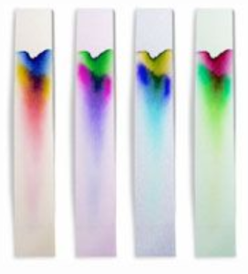
Chromatography - solutions
Chromatography is a technique that is used to separate mixtures of liquids. Colours in inks, food dyes and other mixtures of colours. A medium, such as blotting or filter paper, containing a spot of the mixture is placed in contact with a solvent (e.g. water). Different colours move at different rates through the medium and so they separate along its length.

